From: rozfrank14[ at ]yahoo.com
Subject: Vedr.: Mystery photograph
Date: 21. juni 2006 23.54.23 MET
To: claus emmeche

From: Roslyn Frank <rozfrank14[ at ]yahoo.com>
Date: 17. juni 2006 1.43.06 MET
To: inip[ at ]ysn.ru
Subject: Vs: RE: A question

Dear Claus,

Here is a copy of the "mystery" photograph, along with an email I sent off a short while back trying to get more information about it.

Best,

Roz

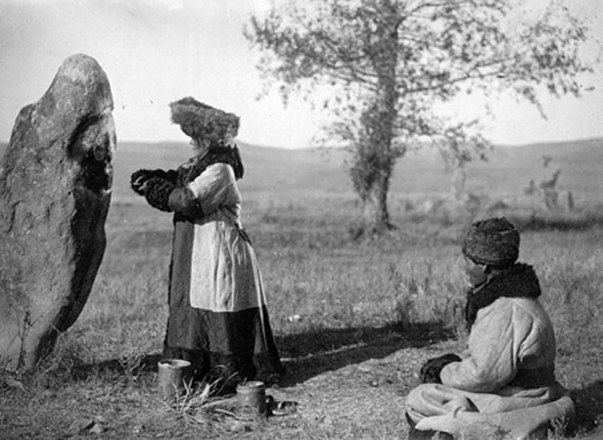

[pict.link: http://www.nbi.dk/~natphil/worldpicture/shamanfeedingstone.html]

Note: forwarded message attached.

From: Roslyn Frank <rozfrank14[ at ]yahoo.com>
Date: 17. juni 2006 1.43.06 MET
To: inip[ at ]ysn.ru
Subject: Vs: RE: A question

- - - - Note: forwarded message attached. - - -

From: Roslyn Frank <rozfrank14[ at ]yahoo.com>
Date: 17. juni 2006 1.32.40 MET
To: www[ at ]www-sbras.nsc.ru
Subject: RE: A question

Dear Sir/Madam:

I am writing to inquire about the photograph that was on your web page in 2000.

Here is the url:

http://www.nsc.ru/museum/shaman/2384_140.jpg

http://www.nsc.ru/museum/shaman/index.html
For some years I have tried to obtain more information about this photo, but without success.

I am attaching a copy of the photo which I downloaded from your web site six years ago.

Currently I am preparing a publication and would very much like to include a discussion of this photograph.

I have discussed this matter with Kira Van Deusen (kiravan[ at ]imag.net) at some length. However, we have not been able to definitively identify the location where the photo was taken or which group of Siberian peoples are pictured in it.

In my correspondence with Kira, she wrote the following commentary on March, 17, 2006:

I was thinking Sakha Yakutia, but now think that's because the photo
itself reminds me of another one. Could be Buriatia as you say, but the stone itself reminds me strongly of Khakassia or Tuva. Costume doesn't look Tuvan though although it could be Buriat or Khakassian....
Unfortunately the landscape could be any of those, or other places as well.
Were you ever looking at a site from Russian Academy of Sciences
Novosibirsk? I remember seeing some old photos up there one time, but
now can't find it.....
I'm going to send this on to a Khakassian friend of mine and see if it rings any bells.
Wow - I hadn't noticed the man in the stone circle in the background!
Cool.
You know those stone circles are absolutely all over the place in Tuva and Khakassia. Also Mongolia I suppose.

My own research has concentrated on shamanic beliefs and performance art. Also, I have have done extensive work on the stone circles of Europe and would like to bring the similar structures, found in Siberia, to the attention of the European community of scholars.

Thank you in advance for any help that you might be able to offer.

Best wishes,

Roslyn M. Frank

_________________________________________________________
Roslyn M. Frank
Professor Emeritus
Department of Spanish & Portuguese
University of Iowa
Iowa City, IA 52242
Fax: (319)-335-2990
E-mail: roz-frank[ at ]uiowa.edu
http://www.uiowa.edu/~spanport/personal/Frank/Frankframe.htm

-----
[ Back to main: http://www.nbi.dk/~natphil/Siberian.html ]

